**ANALYSIS OF OLYMPIC AND PARALYMPIC GAMES**

A REPORT

*Submitted by*

**ANJALI JAIN – 20BCE1320**

**ARUNIMA AGARWAL - 20BCE1808**

**CSE3020 – Data Visualization (EPJ)**

**Slot – (D1)**

***Project Guide***

***Dr. PARVATHI R***

***Professor and Associate Dean (Academics)***

**B. Tech. Computer Science and Engineering**

IN

**School of Computer Science and Engineering**



**FALL SEMESTER 2023-24**

# **ACKNOWLEDGEMENT**

We wish to express our sincere thanks and a deep sense of gratitude to our project guide, **DR. PARVATHI R.**, Professor and Associate Dean (Academics), School of Computer Science and Engineering, VIT Chennai, for her consistent encouragement and valuable guidance pleasantly offered to us throughout the project work.

We are extremely grateful to **DR. GANESAN R.**, Dean of the School of Computer Science of Engineering, VIT Chennai, for extending the facilities of the School towards our project and for his unstinting support.

We express our thanks to our Head of the Department **DR. NITHYANANDAM P.**, VIT Chennai, for his support throughout this project.

We also take this opportunity to thank all the faculty of the School for their support and the wisdom imparted to us throughout the course.

We thank our parents, family, and friends for bearing with us throughout our project and for the opportunity they provided us to undergo this course in such a prestigious institution.

**CONTENTS**

|  |  |  |
| --- | --- | --- |
| **Chapter** | **Title** | **Page** |
|  | Title Page | i |
|  | Acknowledgement | ii |
|  | Abstract | iv |
| 1 | Introduction | 5 |
| 2 | Literature Survey | 7 |
| 3 | Proposed Methodology | 10 |
| 4 | Implementation | 14 |
| 5 | Results and Discussions | 16 |
| 6 | Future Work and Conclusion | 32 |
| 7 | References | 33 |

**ABSTRACT**

The Olympic Games are international sporting events in which more than 200 nations participate in various competitions. Athletes from different countries compete and make their countries proud of their excellence in sports. The Paralympic Games are international sporting events for athletes with physical disabilities. Despite the huge population, many of the most populous countries don't get many medals at the Olympics. We have also seen that the number of female participants has increased over the last ten years. The main objective of this project is to analyze the Olympics and Paralympics dataset with R and Tableau to compare the overall performance of the countries, assess each country's contribution to both the Games, and see the increase in the gender ratio.

We focus on factors such as the sport, the economy, etc. to analyze women's participation. These analyzes will provide a deeper insight into countries' performances at the Games over the years, helping athletes to quickly analyze their performance and that of their competitors. By the end of this project, we will be able to learn the exploratory data analysis techniques used to allow comparison between the performance of different countries and each country's contribution to the Olympic and Paralympic Games in terms of gender. Visualizing the datasets in many ways provides the status of the countries in these Games and helps the underperforming countries to produce high-quality players and improve their nation's performance in the Olympics and Paralympics. Most importantly, we will be predicting the increase in the number of athletes gender-wise in both Summer and Winter Olympics.

**Keywords:** Olympic games, Paralympic games, Datasets, R, Tableau, Gender ratio, Athletes

**1. INTRODUCTION**

The Olympic Games are considered the most important event in the world and provide a common platform for players from different nations to show their talent. The Olympic Games began in 1896 and are held every four years. It encompasses the value of honesty, determination, hard work, and self-discipline. Thousands of athletes compete every four years, but beyond that, the games are not just between athletes but between nations. Olympians are their country's symbol of honor. They represent their nation and show the world that their country has what it takes to compete with the world. At the Olympic Games, the winners of each sporting event are awarded Gold, Silver, and Bronze medals for first, second, and third place. These Olympic medals are held in high regard in the sporting world and the Olympic gold medal is considered the highest achievement by an athlete. Today, most countries try to win medals for their country in Olympic events, and thousands of athletes train for years with the goal of winning a medal in the Olympics.

The Paralympic Games is a major international multisport event that attracts athletes with a variety of disabilities including reduced muscle strength, reduced passive range of motion, limb weakness, unequal leg length, short stature, hypertension, ataxia, athetosis, visual impairment and mental impairment. The IPC has identified ten categories of disabilities, including physical, visual, and intellectual disabilities.

The goal of this paper is to analyze the Olympics and Paralympics dataset with R and Tableau to compare performance and participation of nations in Olympics and Paralympics in recent times. In addition, the field of sports of particular country in particular year, in which they have contributed the maximum can be identified. The comparison of the performance of each sports with other can be done. The field of sports that has to have more participation can be identified and necessary action can be taken by players and nations to enhance themselves in future contributions towards Olympics. Assessment on increase in gender ratio has been done as well.

We focus on factors such as the sport, the economy, etc. to analyze women's participation. These analyzes will provide a deeper insight into countries' performances at the Games over the years, helping athletes to quickly analyze their performance and that of their competitors. By the end of this project, we will be able to learn the exploratory data analysis techniques used to allow comparison between the performance of different countries and each country's contribution to the Olympic and Paralympic Games in terms of gender. Visualizing the datasets in many ways provides the status of the countries in these Games and helps the underperforming countries to produce high-quality players and improve their nation's performance in the Olympics and Paralympics.

* 1. **Problem Statement**

Despite the global recognition and celebration of the Olympic and Paralympic Games, there is a need for a comprehensive analysis of the performance and participation of nations in these events. The existing datasets contain valuable information that, if analyzed systematically, can offer insights into various aspects, including the comparative performance of countries, the distribution of medals, and the evolution of gender representation. Such an analysis is crucial for enhancing the understanding of the dynamics within the Games and can provide valuable information for nations, athletes, and sports organizations.

**2. LITERATURE SURVEY**

The realm of sports research has witnessed a surge in interest concerning the analysis and prediction of athletes' performance in the Summer and Winter Olympics. The convergence of historical data, machine learning techniques, and exploratory data analysis has paved the way for a nuanced understanding of the factors influencing outcomes. This literature survey delves into the methodologies employed in predicting performance, the use of machine learning for heuristic predictions at the country level, the significance of viewpoint-based analysis, and the development of a conceptual model through an extensive examination of existing literature. In previous papers, prediction has been made on their win by using the maximum value scored by the players in their past participation along with the chance of winning gold has been identified.

A prevalent approach to predicting Olympic performance involves scrutinizing athletes' past achievements. Researchers have consistently emphasized the role of historical data, exploring trends and patterns to forecast future success. The maximum values scored by athletes in their past participations serve as indicators of their potential performance in upcoming Games. Scholars argue that athletes who have demonstrated excellence in the past are likely to continue their success, forming the foundation for heuristic predictions.

Furthermore, the connection between winning a medal in previous Olympics and the likelihood of winning in subsequent competitions has been a subject of interest. Studies have explored the correlation between past success and future outcomes, highlighting the predictive power of athletes' track records. This relationship not only aids in forecasting individual performances but also contributes to strategic planning for athletes and their respective teams.

The chances of a person winning a medal in the upcoming Olympics can be predicted if the player wins a medal in their previous participation. Also, with the Olympics performance data for the past games, predicting any player’s future performance has been done. Also with the predicted data has been found by analyzing the data, the performance of the player can be improved like for example, if he/she is not performing better in some areas, analyzing the data can find it out and hence the performance can increases by giving them different training programs which will provide considerable measure in their outcomes.

Beyond prediction, the analysis of past Olympics performance data has proven instrumental in enhancing athletes' future performances. By employing sophisticated data analysis techniques, researchers can identify specific areas of weakness or underperformance. This information becomes invaluable for designing targeted training programs, addressing individual athletes' unique needs. The ability to pinpoint and rectify shortcomings through data-driven insights has shown promise in optimizing athletes' overall performance.

Machine learning techniques have emerged as powerful tools for heuristic prediction, particularly at the country level. Efficiency analysis, coupled with an understanding of the societal importance of sports, forms the basis for machine learning models. These models leverage large datasets, employing advanced algorithms to estimate the success or failure of each country in upcoming Olympic Games. The integration of machine learning into predictions contributes to more nuanced and comprehensive insights, aiding decision-makers in resource allocation and strategic planning.

In the study of sports categories, there has been a notable shift towards viewpoint-based analysis, with video content analysis playing a pivotal role. Unlike structured data, video content provides interior information that is crucial for understanding the intricacies of athletes' performances. Scholars argue that a spatiotemporal viewpoint enhances the depth of analysis, capturing nuances that may be overlooked in traditional numerical data. Video content analysis stands as a valuable complement to other methodologies, offering a more comprehensive understanding of athletes' strengths and weaknesses.

Exploratory Data Analysis (EDA) serves as a fundamental component of the analytical toolkit, offering a thorough understanding and statistical analysis of Olympic data. Visual tools, such as charts and graphs, are employed to uncover patterns, trends, and outliers within the data. EDA enhances the interpretability of complex datasets, providing researchers and stakeholders with a visual narrative of the factors influencing performance. The synergy of visual tools with analytical methods contributes to a more holistic comprehension of the data.

The disparity in performance among different countries in the Summer and Winter Olympics has been a subject of extensive study. Researchers undertook a comprehensive examination utilizing data from the 2000 Olympic Games, encompassing 80 countries and 921 medals. The selection of this dataset allows for a detailed exploration of factors contributing to performance discrepancies among nations. Scholars aim to uncover the socio-cultural and contextual influences that play a pivotal role in shaping countries' Olympic performances.

To underpin the study, an extensive literature survey was conducted to provide a conceptual background. The conceptual model developed through this survey serves as the framework for understanding the complexities of Olympic performance. Researchers synthesized insights from various methodologies, integrating them into a cohesive model that captures the predictive and explanatory power of past performance data. This model becomes a valuable tool for scholars, analysts, and policymakers seeking to navigate the intricate landscape of Olympic competition.

**3. PROPOSED METHODOLOGY**

**3.1 Overall Architecture**

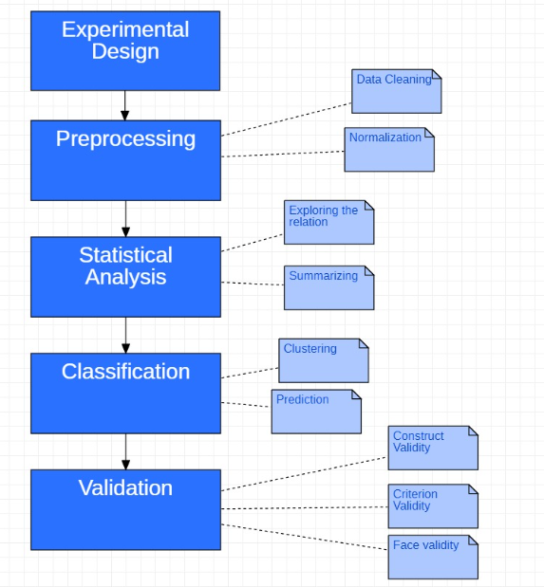

Fig. 1 Architecture

* + Experimental Design
    - Analysing Olympics and Paralympics dataset to compare the overall performance of the countries, assess each country's contribution to both the Games, and see the increase in the gender ratio.
  + Pre-processing
    - Removing all unnecessary values (NA and duplicate values) and normalizing the datasets
  + Statistical Analysis
    - Exploring the relation between the games year-wise and gender-wise and summarizing the observations
  + Classification
    - Clustering the available data and predicting the output
  + Validation
    - Constructing validity of the dataset and setting a particular criteria. Also doing face validity for better analysing

**3.2 Class Diagram**

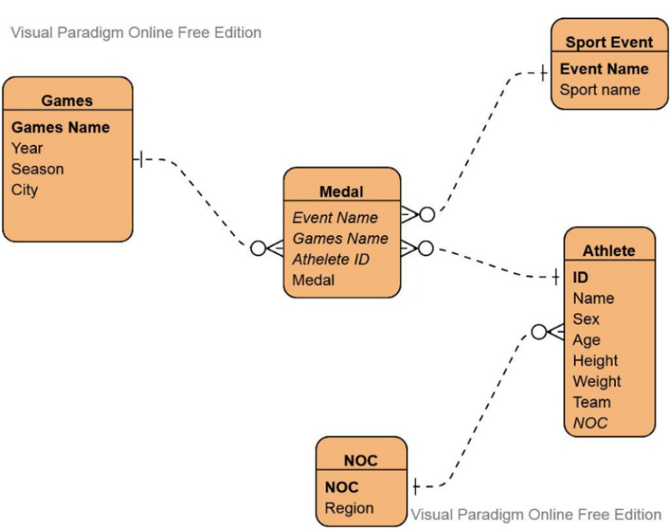

Fig. 2 Class Diagram

In this diagram, associations between classes are represented by lines connecting them. For example:

The Game class may have an association with the Medal class, indicating that an Olympic game involves various athletes who win medals in that respective game.

The Sport Event class is associated with the Medal class, as each event belongs to a specific game and the medals won in that game.

The Athlete class is associated with the Medal and NOC class, showing that an athlete represents a particular country or region and various Athletes win different medals (either gold, silver or bronze).

The Medal class is associated with both the Event and Game classes, indicating which athlete won which medal in a specific event.

* 1. **Module Description**
  + Athlete Performance Prediction
    - Machine Learning algorithms can be used to predict athlete performance based on various factors such as historical data, training regimes, and environmental conditions. Researchers can use regression models to create predictive models that evaluate an athlete's potential performance in various competitions. These models can help coaches customize training plans and make strategic judgments during tournaments.
  + Event Outcome Analysis
    - Classification algorithms can be used to forecast event outcomes, such as which country will win a specific event. ML models can provide insights into which elements are most relevant in choosing winners by examining historical data, athlete profiles, and current form. This data could be useful for sports analysts, broadcasters, and organizations.
  + Paralympic Classification
    - Machine learning approaches can help refine classification systems used in Paralympic sports. By examining athletes' physical traits and performance, ML algorithms can help ensure that competitors are accurately classified, fostering fair competition and increasing the games' diversity.
  + Sports Strategy Optimization
    - Machine learning algorithms can be used to make strategic decisions in team sports. Coaches can build data-driven strategies to combat other teams' strengths and utilize their weaknesses by researching their opponents' playing styles, historical data, and current form.
  1. **R Packages Used**
  + dplyr - A set of functions designed to enable dataframe manipulation in an intuitive, user-friendly way.
  + gganimate - gganimate is an extension of the ggplot2 package for creating animated ggplots. It provides a range of new functionality that can be added to the plot object in order to customize how it should change with time.
  + gridExtra - Provides a number of user-level functions to work with "grid" graphics, notably to arrange multiple grid-based plots on a page, and draw tables.
  + ggplot2 - plotting package that provides helpful commands to create complex plots from data in a data frame.
  + tidyverse - an opinionated collection of R packages designed for data science. All packages share an underlying design philosophy, grammar, and data structures.
  + reshape2 - reshape2 is a package that allows us to easily transform our data into whatever structure we may need.
  + knitr - package that enables integration of R code into LaTeX, LyX, HTML, Markdown.
  + data.table – extension of data.frame.
  + tidytuesdayR - 'TidyTuesday' is a project by the 'R4DS Online Learning Community' in which they post a weekly dataset onto post a weekly dataset in a public data repository (<https://github.com/rfordatascience/tidytuesday>) for people to analyze and visualize. This package provides the tools to easily download this data and the description of the source.
  1. **Hardware/Software Requirements**
* Hardware Requirements
  + Windows 10/11 Operating System with 8 GB RAM with enough disk space
* Software Requirements
  + R for Windows 4.2.1
  + Rtools 4.2
  + RStudio IDE
  + Tableau Desktop 2021.4.4

**4. IMPLEMENTATION**

**4.1 Procedure**

1. Data acquisition – The data from two csv files – 120 years of Olympics, and Tokyo 2020 Olympics – was read using the read.csv command in R. The data from Paralympic-Medals dataset was acquired from the tidytuesdayR package in R.
2. Datasets
   * “120 years of Olympic history: athletes and results” - 15 columns (ID,Name,Sex ,Age,Height,Weight,Team,NOC,Games,Year,Season ,City,Sport,Event ,Medal) (<https://www.kaggle.com/datasets/heesoo37/120-years-of-olympic-history-athletes-and-results>)
   * “Tokyo 2020 Olympics Dataset” - 12 columns ("X" , "Code", "Name", "Gender", “Age", "NOC", "Country", "Discipline", "Sport", "Event", "Rank", “Medal") (This dataset consists of every event in which an athlete participated together with age, nationality, ranks and medals in the 2020 Tokyo Olympics.) (https://www.kaggle.com/datasets/aliaamiri/2020-summer-olympics-dataset)
   * The “Paralympic-Medals” dataset from the tidytuesdayR package in R - Used the TidyVerse package in R to perform data wrangling and EDA on a dataset with 19,000+ rows about Paralympic medals won between 1980 and 2016. 10 columns ("gender", "event", "medal", "athlete", "abb", "country", "grp_id", "type", "year", "guide")
   * https://data.world/johayes13/summer-winter-olympic-games
   * https://figshare.com/articles/dataset/The_Olympic_and_Paralympic_Games_Rio_2016_proposals_for_educational_participation_and_elite_sport/20012086
3. Data Cleaning – From two datasets - 120 years of Olympics, and Tokyo 2020 Olympics – NA values were found and replaced, and also duplicate rows from the datasets were eliminated. From the Paralympic-Medals dataset, a lot more cleaning was involved. Replacing NA values, replacing incorrect names of athletes, removing rows with wrong information, etc.
4. Data analysis – Firstly, data was analyzed from the 120 years of Olympics, and Tokyo 2020 Olympics. After that, from the Paralympic-Medals dataset. Finally, a gender-based analysis was performed on 120 years of Olympics, and Tokyo 2020 Olympics datasets. Based on the output, future predictions were made.

**5. RESULTS AND DISCUSSION**

**A. Analysis of the “120 years of Olympics dataset”**

1. Top 10 Regions with highest medals in Summer Olympics

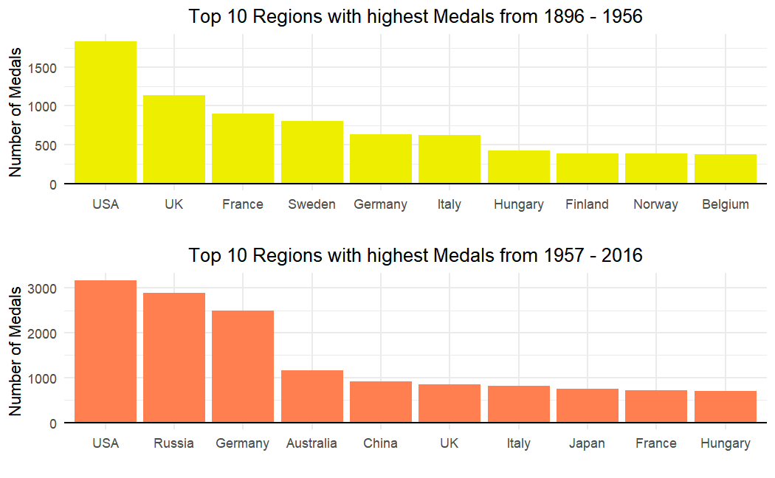

Fig. 3 Top 10 Regions with Highest Medals in Summer Olympics from 1896-2016

1. Top 10 Regions with highest medals in Winter Olympics

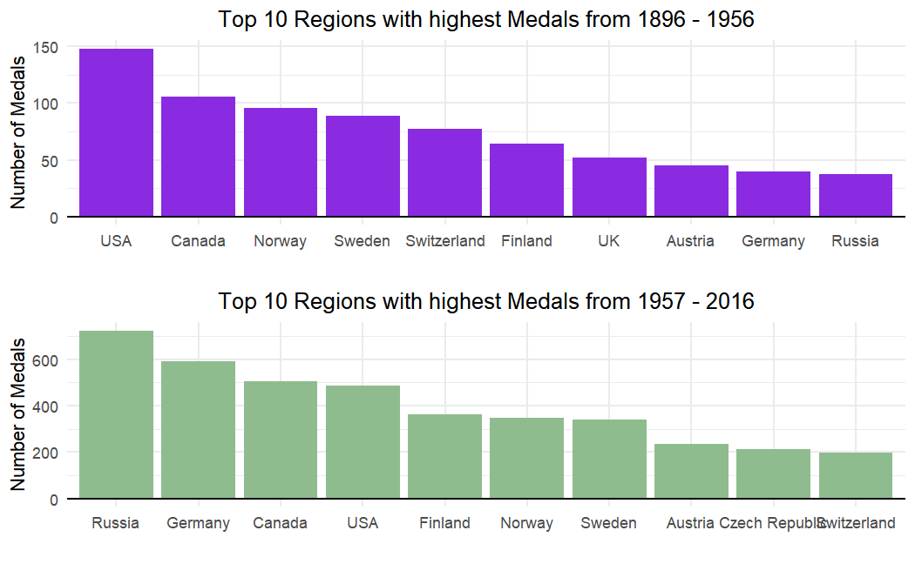

Fig. 4 Top 10 Regions with Highest Medals in Winter Olympics from 1896-2016

1. Medals won by Males/Females over time in Summer Olympics

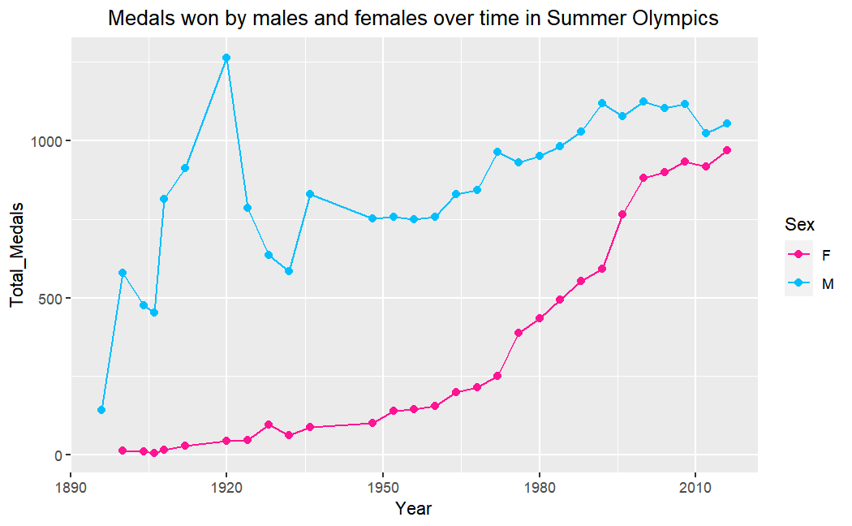

Fig. 5 Medals won by Males/Females over time in Summer Olympics

1. Medals won by Males/Females over time in Winter Olympics

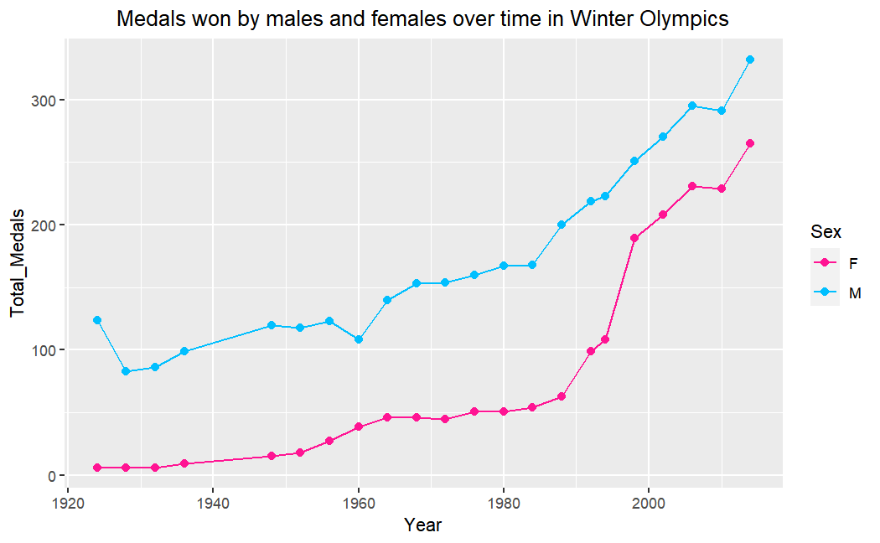

Fig. 6 Medals won by Males/Females over time in Winter Olympics

1. Most participated Sport in Olympic Games every year in Summer Olympics

Year Sport Participation

1896 Athletics 106

1900 Fencing 317

1904 Gymnastics 458

1906 Athletics 470

1908 Athletics 778

1912 Athletics 962

1920 Athletics 849

1924 Athletics 1003

1928 Athletics 992

1932 Art Competitions 620

1936 Athletics 1007

1948 Gymnastics 1060

1952 Gymnastics 2391

1956 Athletics 1013

1960 Gymnastics 1794

1964 Gymnastics 1484

1968 Gymnastics 1496

1972 Athletics 1686

1976 Athletics 1297

1980 Athletics 1268

1984 Athletics 1674

1988 Athletics 2062

1992 Athletics 2054

1996 Athletics 2386

2000 Athletics 2468

2004 Athletics 2175

2008 Athletics 2244

2012 Athletics 2278

2016 Athletics 2508

1. Most participated Sport in Olympic Games every year in Winter Olympics

Year Sport Participation

1924 Speed Skating 110

1928 Ice Hockey 124

1932 Cross Country Skiing 74

1936 Cross Country Skiing 175

1948 Alpine Skiing 360

1952 Alpine Skiing 378

1956 Alpine Skiing 403

1960 Alpine Skiing 320

1964 Alpine Skiing 411

1968 Alpine Skiing 422

1972 Cross Country Skiing 335

1976 Cross Country Skiing 395

1980 Alpine Skiing 327

1984 Cross Country Skiing 477

1988 Alpine Skiing 668

1992 Alpine Skiing 750

1994 Cross Country Skiing 639

1998 Cross Country Skiing 733

2002 Cross Country Skiing 774

2006 Cross Country Skiing 812

2010 Cross Country Skiing 725

2014 Cross Country Skiing 765

**B. Analysis of the “Paralympics-Medals” dataset**

1. Paralympic athletes with the most medals (1980 -2016)

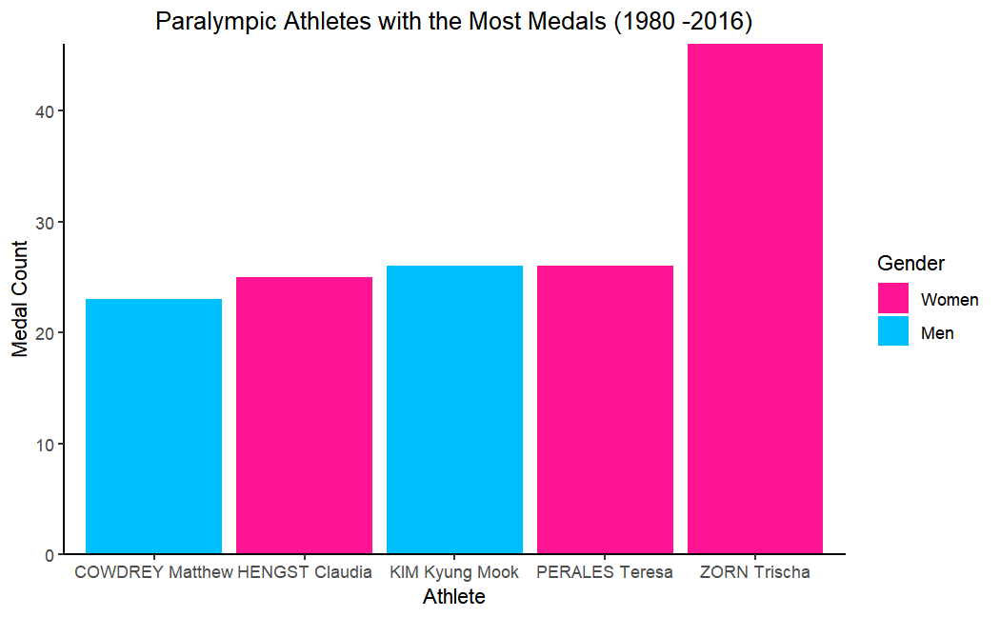

Fig. 7 Paralympic athletes with the most medals (1980 -2016)

1. Top 5 countries with the most paralympic medals for team sports (1980 - 2016)

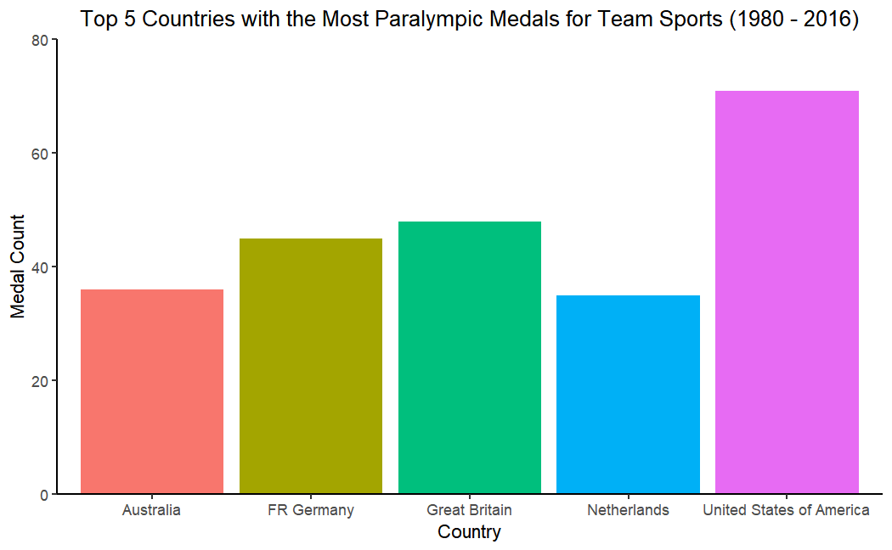

Fig. 8 Top 5 countries with the most paralympic medals for team sports from 1980 – 2016

1. Medals over time for top 5 countries (1980 - 2016)

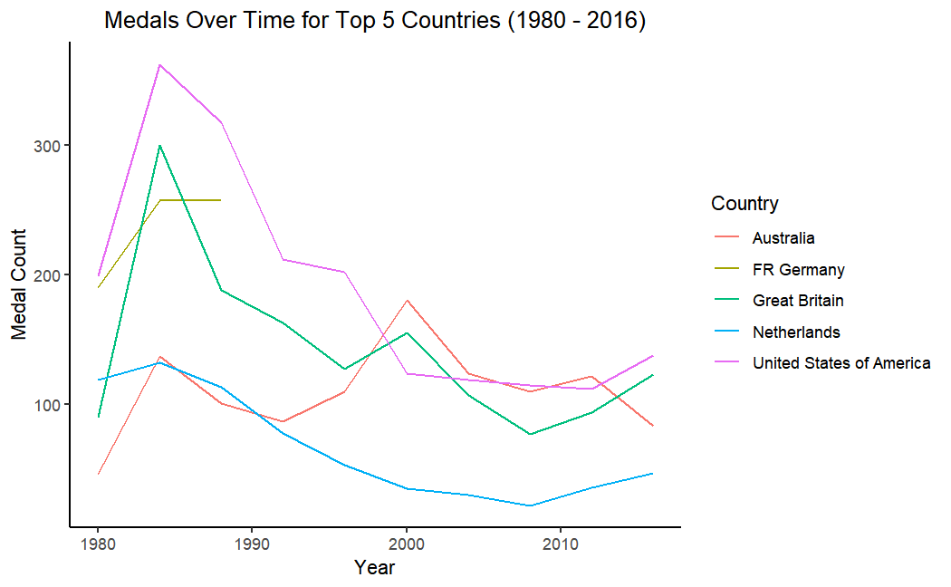

Fig. 9 Medals Over Time for Top 5 Countries from 1980 - 2016

1. Number of athletes gender-wise in Paralympics (1980-2016)

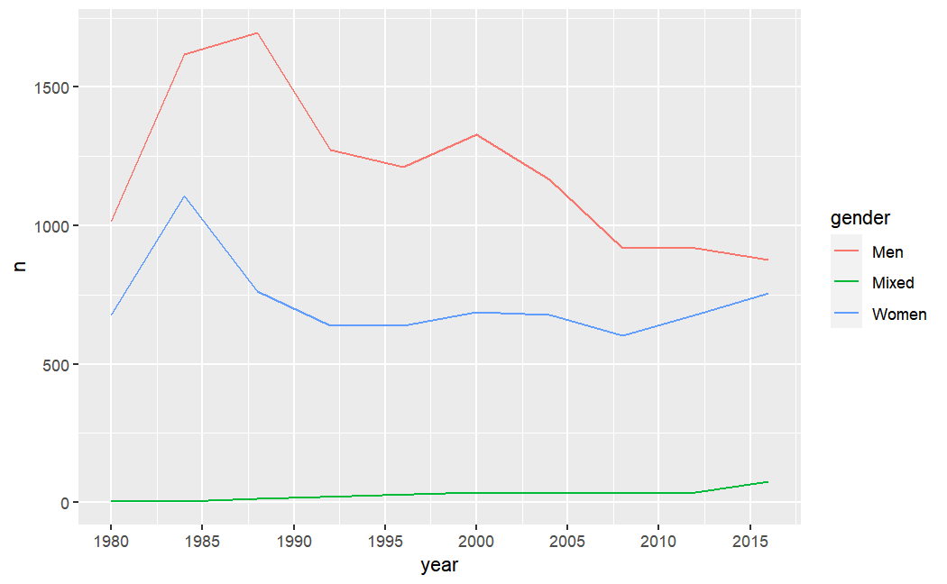

Fig. 10 Number of Athletes Gender-Wise in Paralympics from 1980-2016

1. Tableau Visualization – Number of Men and Women Winning Medals in Summer Paralympics Country Wise

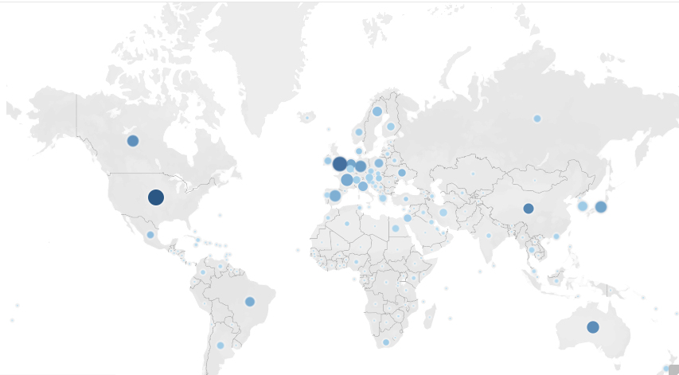

Fig. 11 Number of Men and Women Winning Medals in Summer Paralympics Country Wise

1. Tableau Visualization – Year Wise Trend Between Men and Women in Summer Paralympics

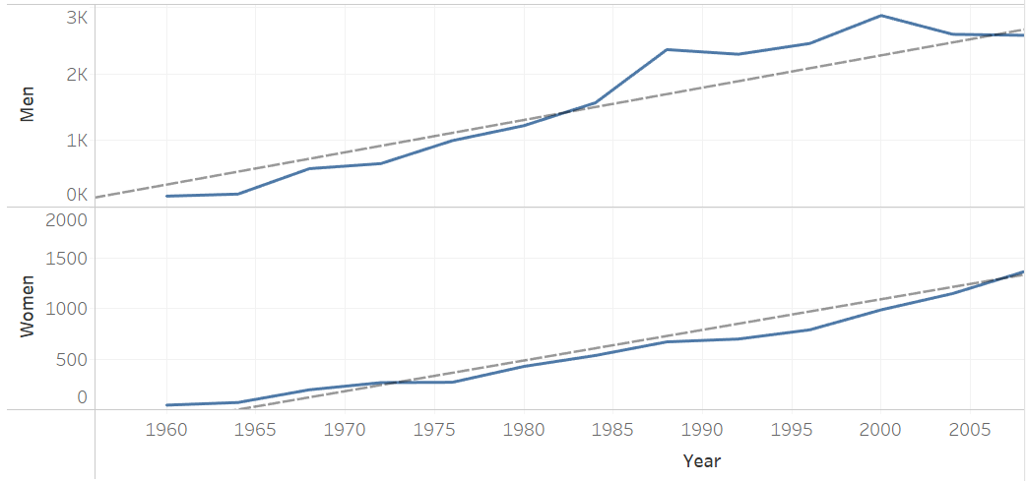

Fig. 12 Year Wise Trend Between Men and Women in Summer Paralympics

1. Tableau Visualization – Number of Men and Women Winning Medals in Winter Paralympics Country Wise

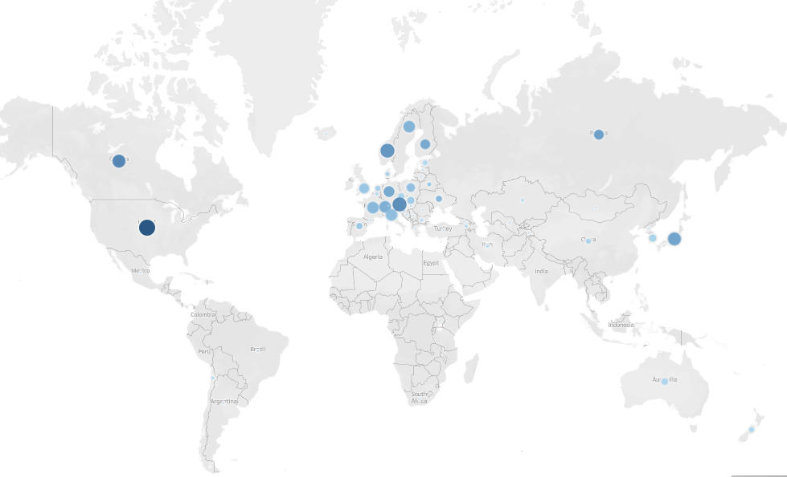

Fig. 13 Number of Men and Women Winning Medals in Winter Paralympics Country Wise

1. Tableau Visualization – Year Wise Trend Between Men and Women in Winter Paralympics

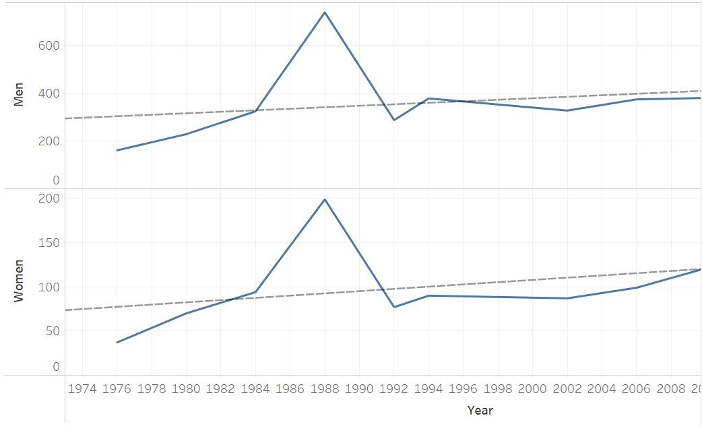

Fig. 14 Year Wise Trend Between Men and Women in Winter Paralympics

1. 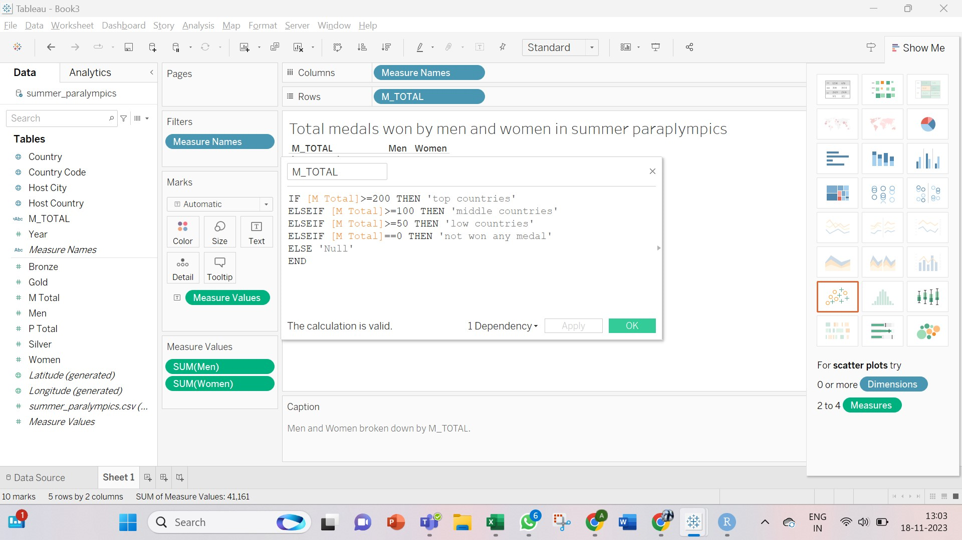Tableau Visualization - Here top countries are referred to those which have won medals greater than 200, Middle countries are those who won medals between 100 and 199, low countries are those who won medals between 99 and 50 medals in total and countries who has not won any medal is termed as ‘not won any medal’.

Fig. 15 Total Medals Won by Countries in Summer Paralympics

1. 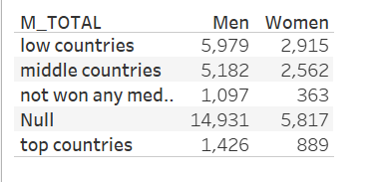Tableau Visualization – Total medals won by countries in summer paralympics along with the number of men and women participating from the corresponding category of country.

Fig. 16 Total Medals Won by Countries in Summer Paralympics with Men and Women Participation Count

1. 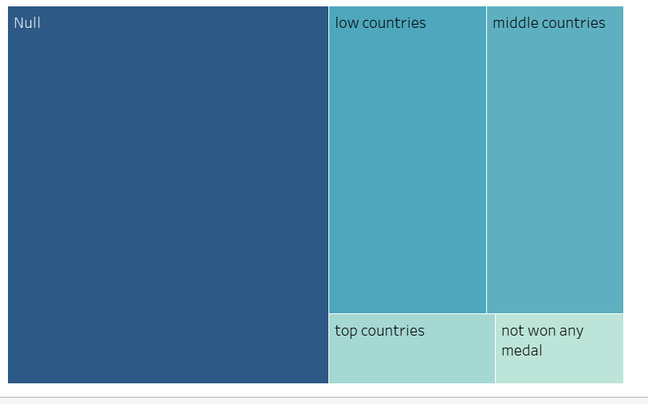Tableau Visualization – Color shows sum of Women. Size shows sum of Men. The marks are labeled by M_TOTAL.

Fig. 17 Total Medals Won by Countries in Summer Paralympics

1. 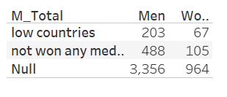Tableau Visualization - Total medals won by countries in winter paralympics along with the number of men and women participating from the corresponding category of country.

Fig. 18 Total Medals Won by Countries in Winter Paralympics with Men and Women Participation Count

1. 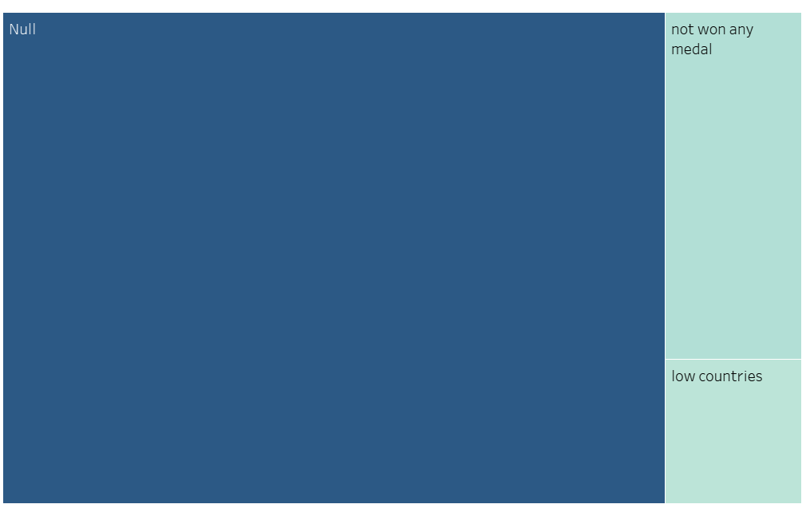Tableau Visualization - Since the greatest number of medals won by any country is 80 in our dataset therefore most of the countries fall under low countries category.

Fig. 19 Total Medals Won by Countries in Winter Paralympics

1. 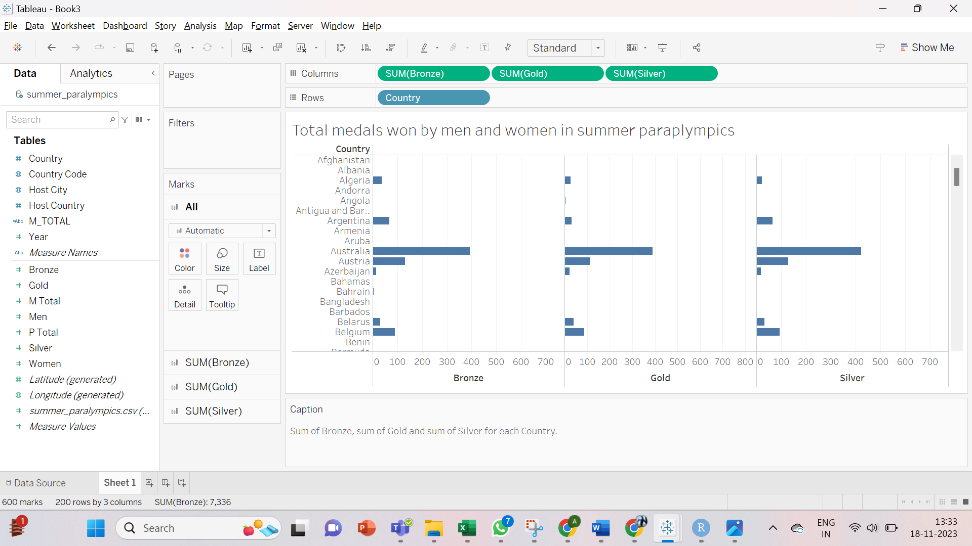Tableau Visualization - Top five countries include Australia, Canada, Great Britain, China, and United States of America.

Fig. 20 Sum of Bronze, Gold, and Silver Medals for Each Country for Summer Paralympics

1. Tableau Visualization - Top five countries include Austria, Germany, Norway, Russia, and United States of America

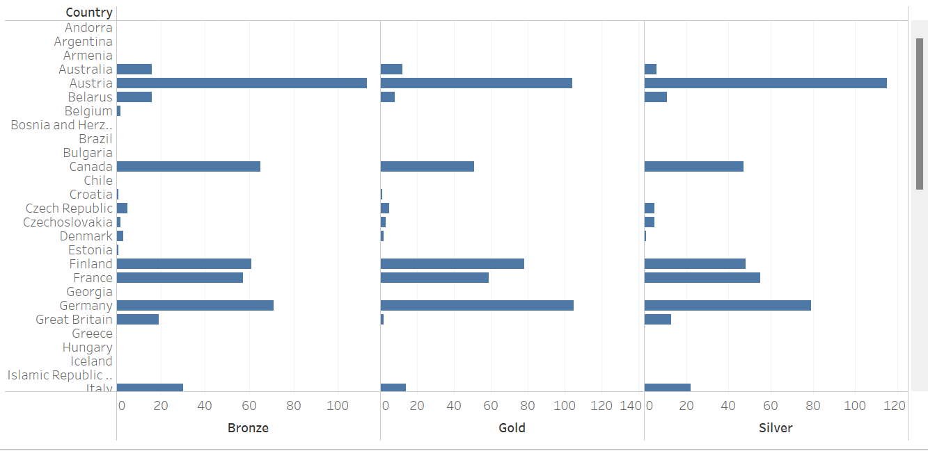

Fig. 21 Sum of Bronze, Gold, and Silver Medals for Each Country for Winter Paralympics

**C. Analysis of the “120 years of Olympics” and “Tokyo 2020 Olympics” dataset and**

1. Number of athletes for each gender in Summer Olympics

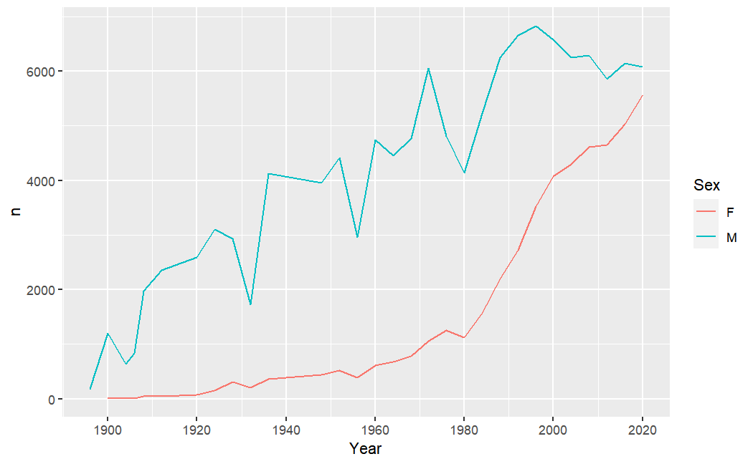

Fig. 22 Number of Athletes for Each Gender in Summer Olympics

1. Predicting the growth of number of athletes in Summer Olympics for the next 10 Olympics

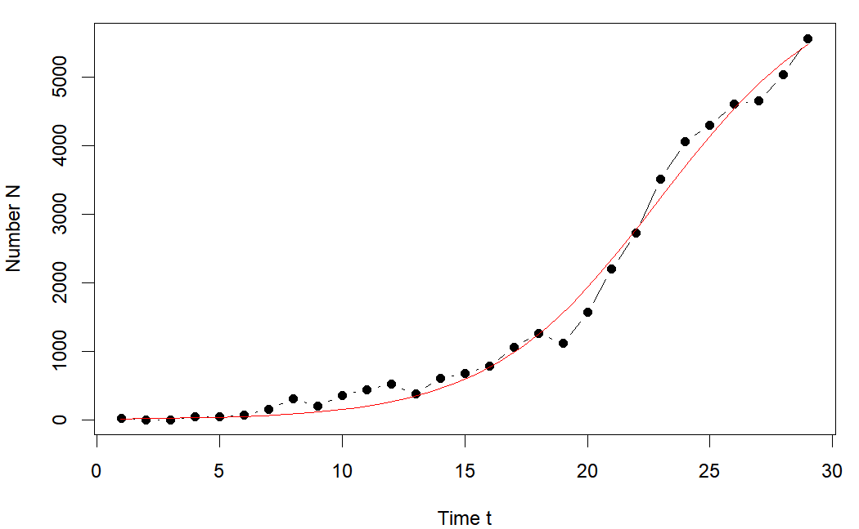

Fig. 23 Model for Female Athletes

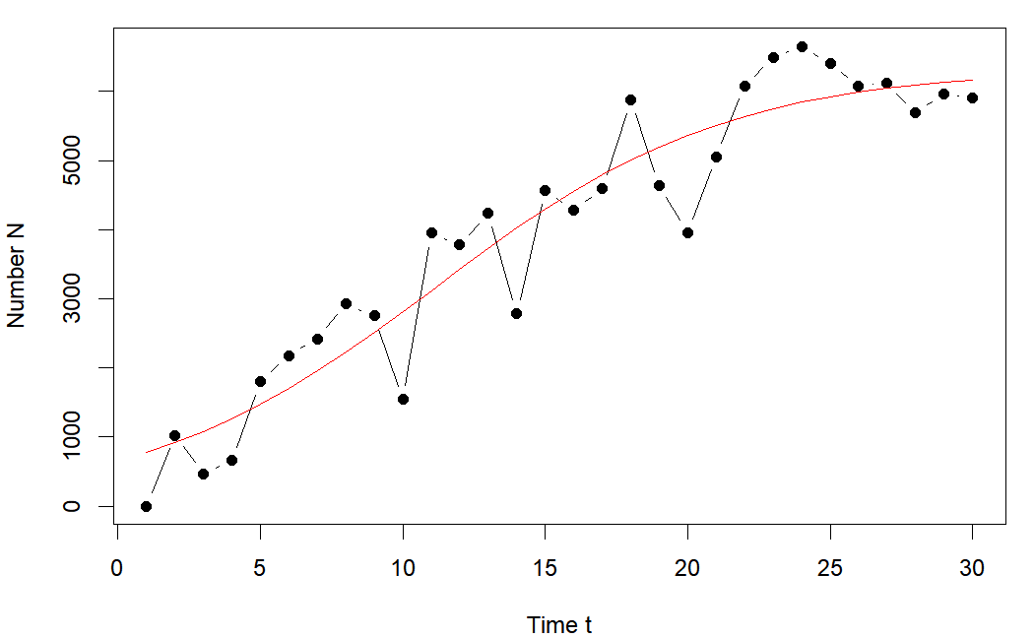

Fig. 24 Model for Male Athletes

Output

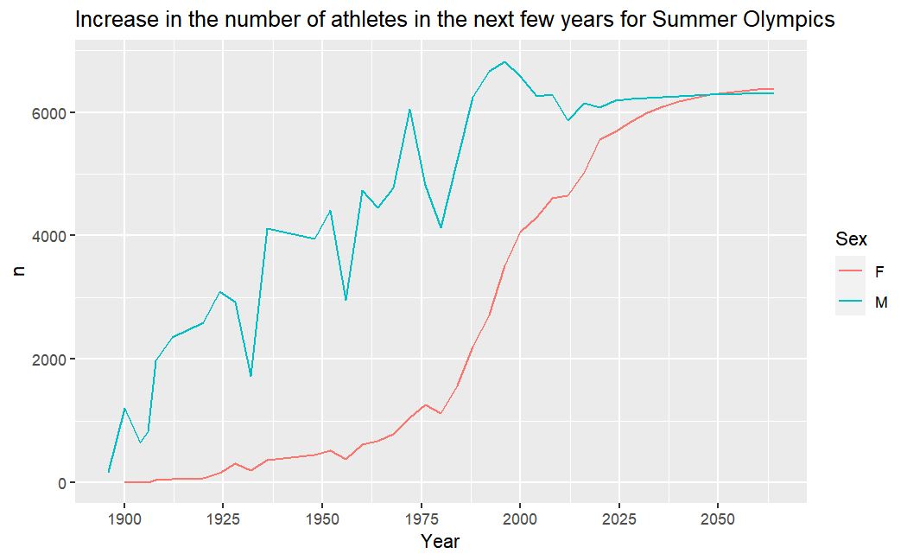

Fig 25. Increase in Number of Athletes (Summer Olympics)

As it is seen from the graph, the number of female athletes are set to increase by a good measure in the next few years and overtake the number of male athletes by around 2045.

1. Number of athletes for each gender in Winter Olympics

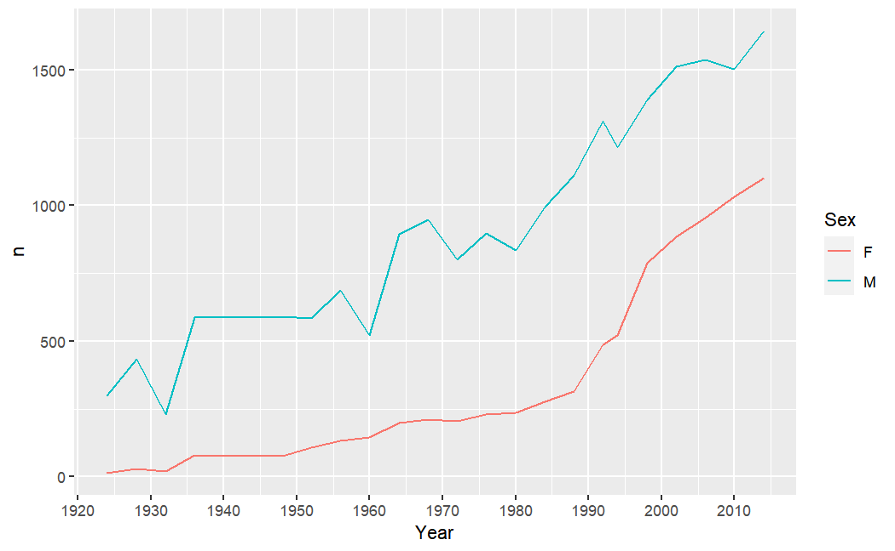

Fig. 26 Number of Athletes for Each Gender in Winter Olympics

1. Predicting the growth of number of athletes in Winter Olympics for the next 10 Olympics

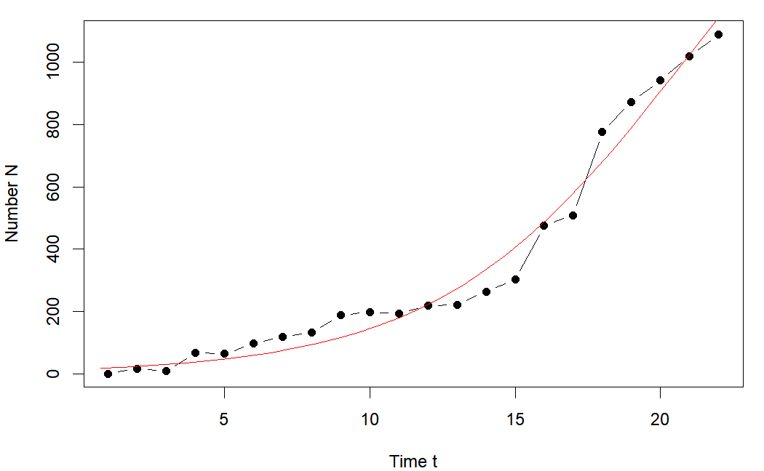

Fig. 27 Model for Female Athletes

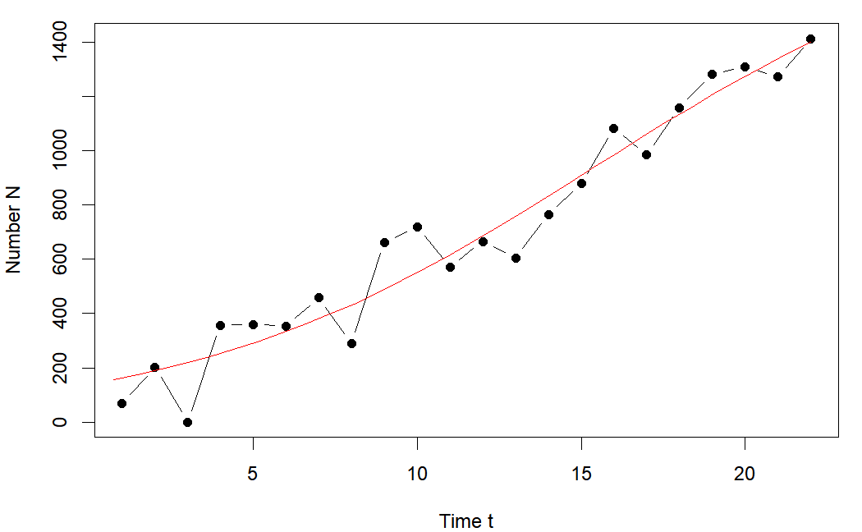

Fig. 28 Model for Male Athletes

Output

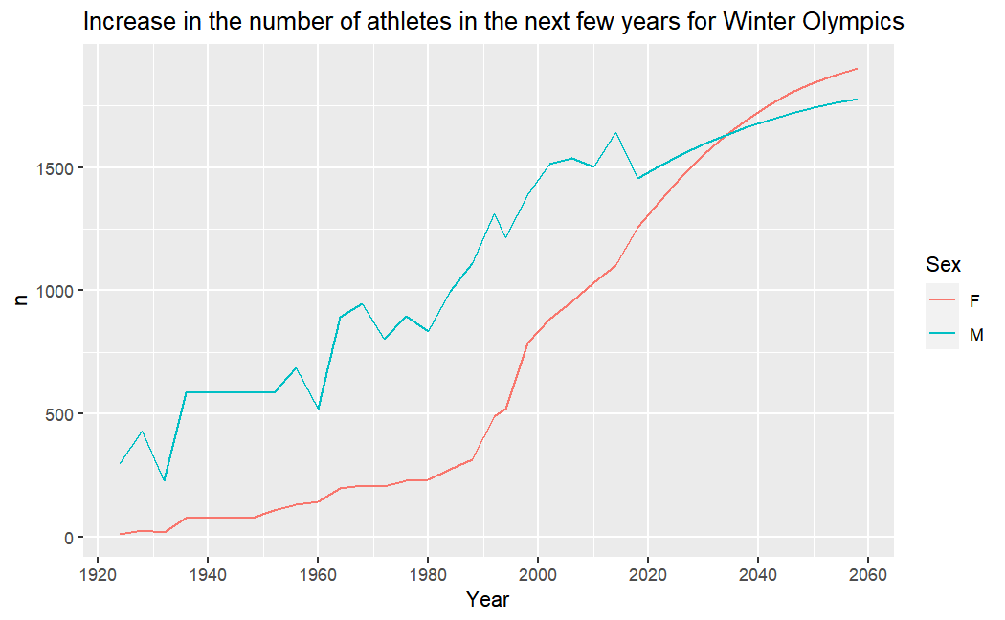

Fig. 29 Increase in Number of Athletes (Winter Olympics)

1. Calculating gold medals for each gender

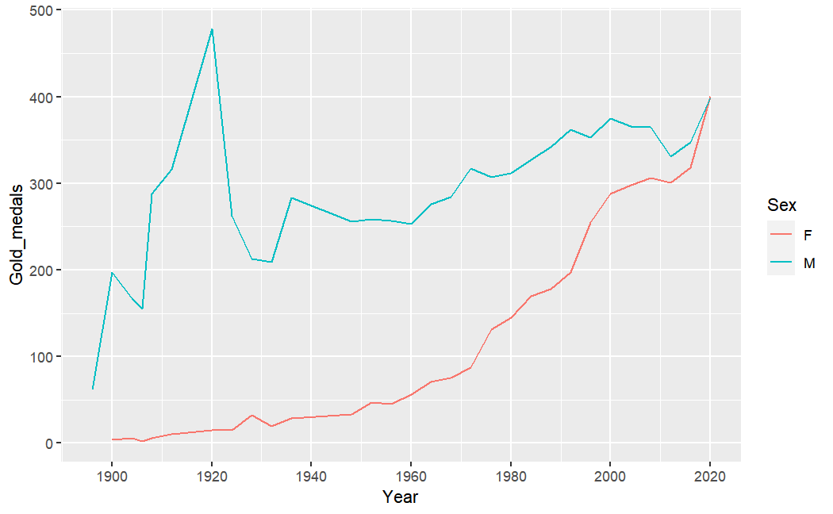

Fig. 30 Gold Medals for Each Gender

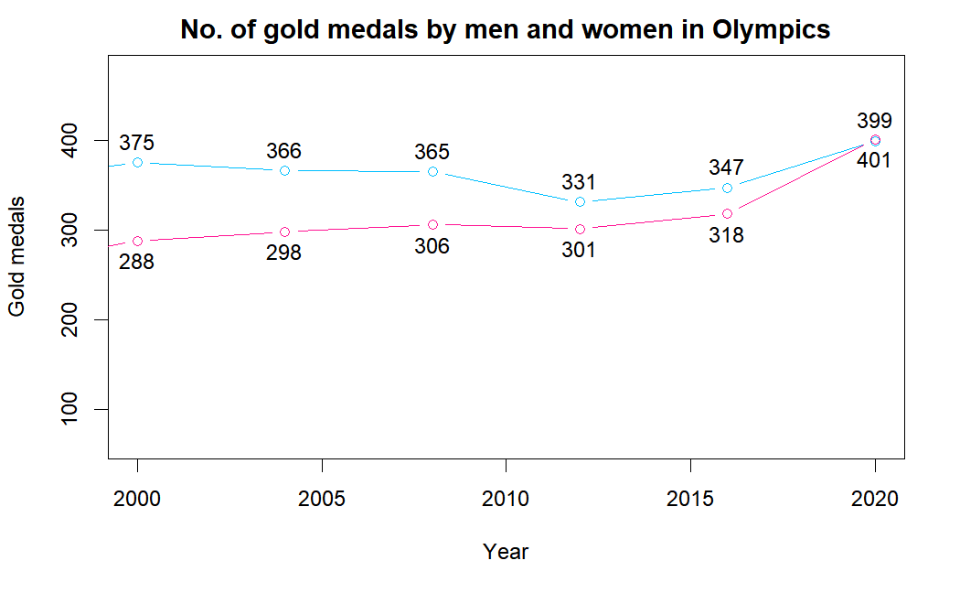

Fig. 31 Gold Medals by Each Gender in Olympics

As it is seen from the second graph above, for the first time in history, women won more gold medals than men – 401 by women and 399 by men – in the 2020 Tokyo Summer Olympics.

**6. FUTURE WORK AND CONCLUSION**

It has been a great pleasure for us to work on this exciting and challenging project. This project proved to be very beneficial as it provided practical knowledge of R and RStudio as well as Tableau. It also provides knowledge about the latest technology used in developing web enabled application and client server technology that will be great demand in future. We also learnt to analyze the Olympics and Paralympics dataset with R to compare the overall performance of the countries, assess each country's contribution to both the Games, and see the increase in the gender ratio based on various factors. Most importantly we learned document creation, importance of knowledge sharing, self and work management, and team work and communication. This will provide better opportunities and guidance in future in developing projects independently.

Moreover, we learnt effective data visualisation using Tableau. Novelty for the project was the analysis of Paralympic Games, both Summer and Winter Games using Tableau. We gained useful insights using Tableau. Future work will include more deeper visualisation on the athletes performance in every Game using different visualisation tools.

**REFERENCES**

1. GitHub. r-olympic-games/main.r at main · cosmoduende/r-olympic-games. Retrieved, October 16, 2022 from <https://github.com/cosmoduende/r-olympic-games/blob/main/main.r>
2. GitHub. Olympic-History-Analytics-in-R/Olympic-History.Rmd at main · Thomas-George-T/Olympic-History-Analytics-in-R. Retrieved, October 16, 2022 from <https://github.com/Thomas-George-T/Olympic-History-Analytics-in-R/blob/main/Olympic-History.Rmd>
3. Kaggle. (2021, October 17). Historical Gender Equality in the Olympics. Retrieved October 20, 2022 from <https://www.kaggle.com/code/aliaamiri/historical-gender-equality-in-the-olympics>
4. Kaggle. Your Machine Learning and Data Science Community. Retrieved October 20, 2022 from <https://www.kaggle.com/>
5. 120 years of Olympic Games - Towards Data Science. Retrieved October 20, 2022 from <https://towardsdatascience.com/120-years-of-olympic-games-56411bc4bd53>
6. GitHub. Olympic-History-Analytics-in-R/Olympic-History.Rmd at main · Thomas-George-T/Olympic-History-Analytics-in-R. Retrieved October 20, 2022 from <https://github.com/Thomas-George-T/Olympic-History-Analytics-in-R/blob/main/Olympic-History.Rmd>
7. Wikipedia contributors. (2022, October 4). Olympic Games. In *Wikipedia, The Free Encyclopedia*. Retrieved 06:43, October 20, 2022, from <https://en.wikipedia.org/w/index.php?title=Olympic_Games&oldid=1114128586>
8. Wikipedia contributors. (2022, October 18). Paralympic Games. In *Wikipedia, The Free Encyclopedia*. Retrieved 06:44, October 20, 2022, from <https://en.wikipedia.org/w/index.php?title=Paralympic_Games&oldid=1116829248>
9. JOUR. (2019). 2016 Olympic Games on Twitter: Sentiment Analysis of Sports Fans Tweets using Big Data Framework. Retrieved, October 26, 2022, from <https://www.researchgate.net/publication/337158792_2016_Olympic_Games_on_Twitter_Sentiment_Analysis_of_Sports_Fans_Tweets_using_Big_Data_Framework>
10. GitHub. julietwomack/TT-Paralympic-Medals: Used TidyVerse to perform data wrangling and EDA on a dataset on Paralympic medals won between 1980 and 2016. Retrieved October 28, 2022 from <https://github.com/julietwomack/TT-Paralympic-Medals>
11. (2017). Growth Curve Analysis and plotting with R. Retrieved October 28, 2022 from <http://rstudio-pubs-static.s3.amazonaws.com/270755_b6a3cb371b0b446891deba7aa7fa55f2.html>
12. Medium. (2021, February 15). Machine Learning For The Olympics. Retrieved October 30, 2022 from <https://amybeisel.medium.com/machine-learning-for-the-olympics-4aa4188e6298>
13. Visual Analysis of Olympics Data - towardsdatascience.com. Retrieved October 31, 2022 from <https://towardsdatascience.com/visual-analysis-of-olympics-data-16273f7c6cf2>
14. Jour. (2019, January 01). Performance analysis in olympic games using exploratory data analysis techniques. Retrieved October November 2, 2022 from <https://www.researchgate.net/publication/330847008_Performance_analysis_in_olympic_games_using_exploratory_data_analysis_techniques>
15. International Journal of Scientific Research in Computer ... – IJSRCSAMS. Retrieved October November 2, 2022 from <http://ijsrcsams.com/images/stories/Past_Issue_Docs/ijsrcsamsv8i1p151.pdf>